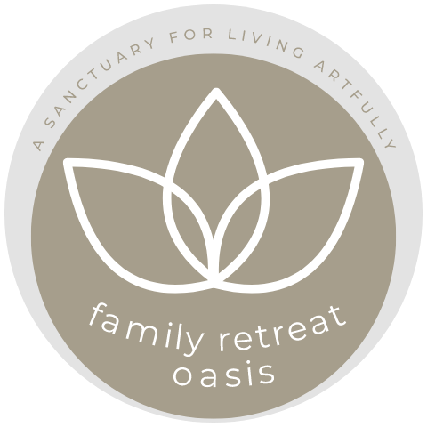

Family Retreat Oasis
Collective Guidelines
Sacred Space and Respect
At Family Retreat Oasis we value safety, acceptance and non-judgement. We like to be mindful of our words and actions. We do our best to avoid negative talk because it creates an unsafe environment and destroys trust. We are all unique with different habits and parenting styles. Please be tolerant of each other. Each person has their own story.
“Before you judge a mother walk a mile in her shoes.”
Children live in the moment. They can be emotional, raucous, cry easily and push our buttons, but as the Yogis say: “This too shall pass.”
If there are moments you feel out of control: Don’t forget to breathe or your sense of humour. Your sense of humour works wonders!.
To hold the sacred, supportive container of Family Oasis, we believe in the magic of the circle and that it’s medicine for our challenging times. In the women’s circle everyone is on the same level.
The circle bypasses hierarchies and systems of control or domination. Each individual is sovereign, radically self-responsible and self-regulating. We are here to share, listen and learn from each other. We practice the art of holding space, where there is nothing to fix and no one needs to feel inadequate or less than. We are all on the journey of remembering and returning to wholeness.
An Invitation to remembering who we are
There are still places and there was a time when women weren’t isolated with the responsibility of raising children, cooking, cleaning, running a household, holding down a job AND making an income. Humans thrived in community where the whole village helped raise the children. Please see this week as an opportunity to experiment with more ancestral forms of co-habitation. If you see another child in need of something, offer to help. All our children are precious because they determine the future of our planet. When you have an anxious moment, why not try this: How would the world be different if I loved your child as if she/he were mine?”
Communal Areas
We kindly ask guests to take care of all items on the properties and also ensure that their children do not damage anything.
Out of respect for the communal space we kindly ask mothers to keep them free from clutter and belongings. We ask you to place your dishes in the designated areas so we can keep things running smoothly.
We like the Family Oasis retreat to be a change from daily life. We would appreciate if electronic gadgets for children could be kept in the rooms and only used there.
Food
Our food concept is based on organic, locally-sourced, nutrient- dense wholefoods. Everything is freshly prepared and we don’t buy or stock any processed junk foods. We invite you to use this week to detox from alcoholic beverages and stimulants but of course don’t stop yourself having a glass of wine if you feel like.
Organic produce is expensive, and we choose to eat organic. We have a budget and aim to be sustainable. When you help yourselves please take the amount you or your child will manage to eat. You can always go for seconds.
We encourage you to use this week to experiment with new foods and tastes. We know children can be fussy eaters and sometimes they don’t feel like eating as much in a new environment, warmer climate or are stimulated by the others. Please don’t worry your child will get plenty of food over the course of each day.

It’s going to be a great week. We invite you to be fully present with a curious mind and an open heart.
When women unite they awaken a sacred wisdom which resides inside each of us, leading to laughter, deep recognition, healing and true magic.

With love and in service,
Evija and your Family Oasis Team

